Corrections 23.03.2016

Accessories:
- This correction applies for both Rugged and Precision. It is currently implemented on Precision – please do the same for Rugged.
  - Move the “select accessories” to the “Basket” page (the customer should be able to select the accessories on the Basket page instead of the Product specific page)

Comments: As I said before that below images are missing as per your given xls file.
Dell Latitude Rugged 14
Dell Latitude Rugged Extreme 12
Dell Latitude Rugged Extreme 14

Please check the attached “20160311_IDEM_Accessories_precision-rugged_to Dhaka_v03.xlsx” rugged product images path.

Only availble Dell Latitude Rugged Tablet 12 R16. When you add this product to cart you will get product related accessories same as precision.

  - We don’t want the customer selecting the accessories on the Product page. Please remove this functionality from this page. Once they selected a product, we want to give them the possibility to select an accessory on the basket page. So if they have chosen a Rugged XXX, on the Basket page we want to show the related accessories for the Rugged XXX selected (not all products).

Comments: Need to provide product images for all rugged product. This functionality already applied for rugged products same as precision.

Workshop email layout to redo

Contact page:
- “My code doesn’t work” is out of place.
- Please replace copy “My code doesn’t work” with: “Select topic”
- Please add “My code doesn’t work” as one option in the drop down menu
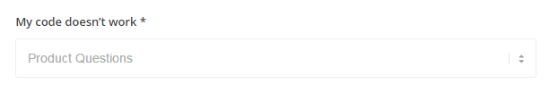
- If the customer lands on the Contatc page because he clicked “My code doesn’t work” on the Gateway page, then the option “My code doesn’t work” should be the selected option by default

Product page:
- Please see attachment with the product specs
- There are different configurations of products for each country. Example of the Mobile Precision 5510 – see below
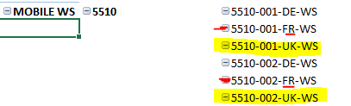

- If a customer is logging in from UK in this case they should see only the UK configurations
- In case of multiple configurations, we want to have options appearing in different tabs on the “Product page” – see screenshot below.
- The name of each tab would be the one on Column C of the excel file” 5510-001-UK-WS” for example
- The “Add to basket” button will be added at the bottom of each tab so that the customer can see different specs for different configurations and decide which one they would like to book
- See screenshot for reference:
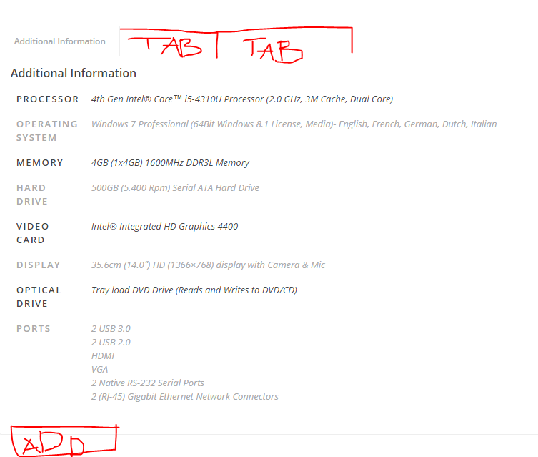

Precision landing page:

- Please remove “Rack as highlighted below”

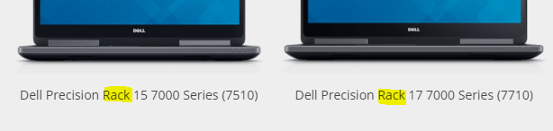

Accessories:
- When customer selects accessories, there should not be a calendar. The accessory is booked by default the same dates as the product

Check out page:
- Move the “Check out button underneath the Accessories

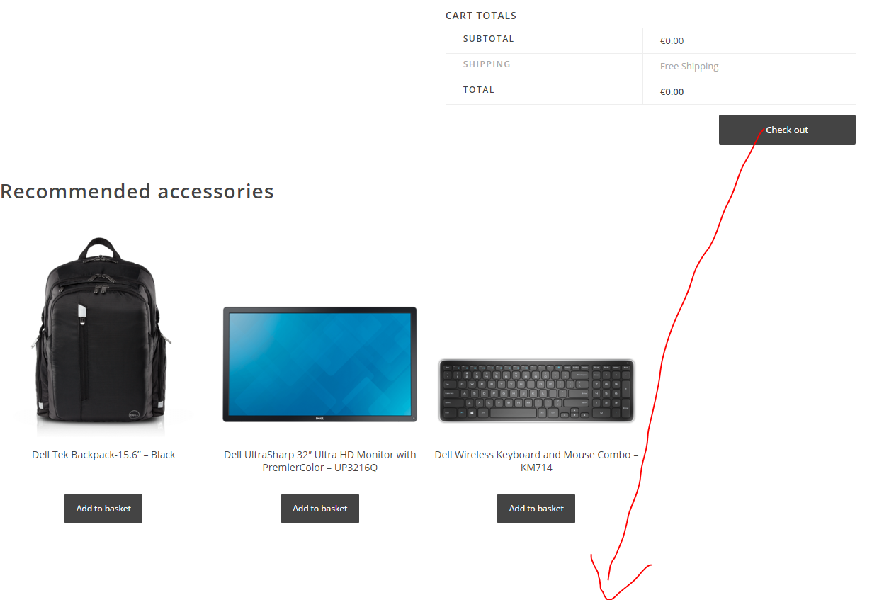

Contact page
- Remove: DFS Precision:
- Change text as below:
Dell Financial Services
Interested in financing a Dell product? Click here to learn how easy monthly payment options from Dell Financial Services can save you money and get the most out of your workflow.
Dell Basic, ProSupport and ProSupport Plus
We offer our commercial customers several ways to reach Dell in different regions. Please have proof of purchase of your Dell ProSupport or ProSupport Plus contract, or have your service tag available so we can verify your eligibility.
- Remove the below paragraph In yellow
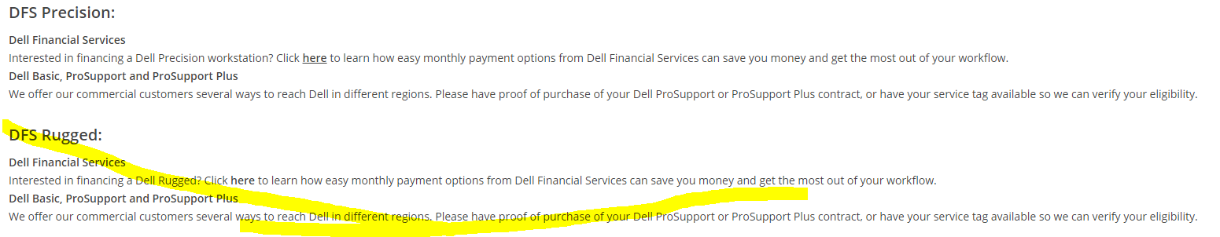

- DFS paragraph should not be appearing for Greece and Poland

Rugged site:
- Please replace the current De& Intel logo with the below one (it’s called Dell and Intel lock up logo)



